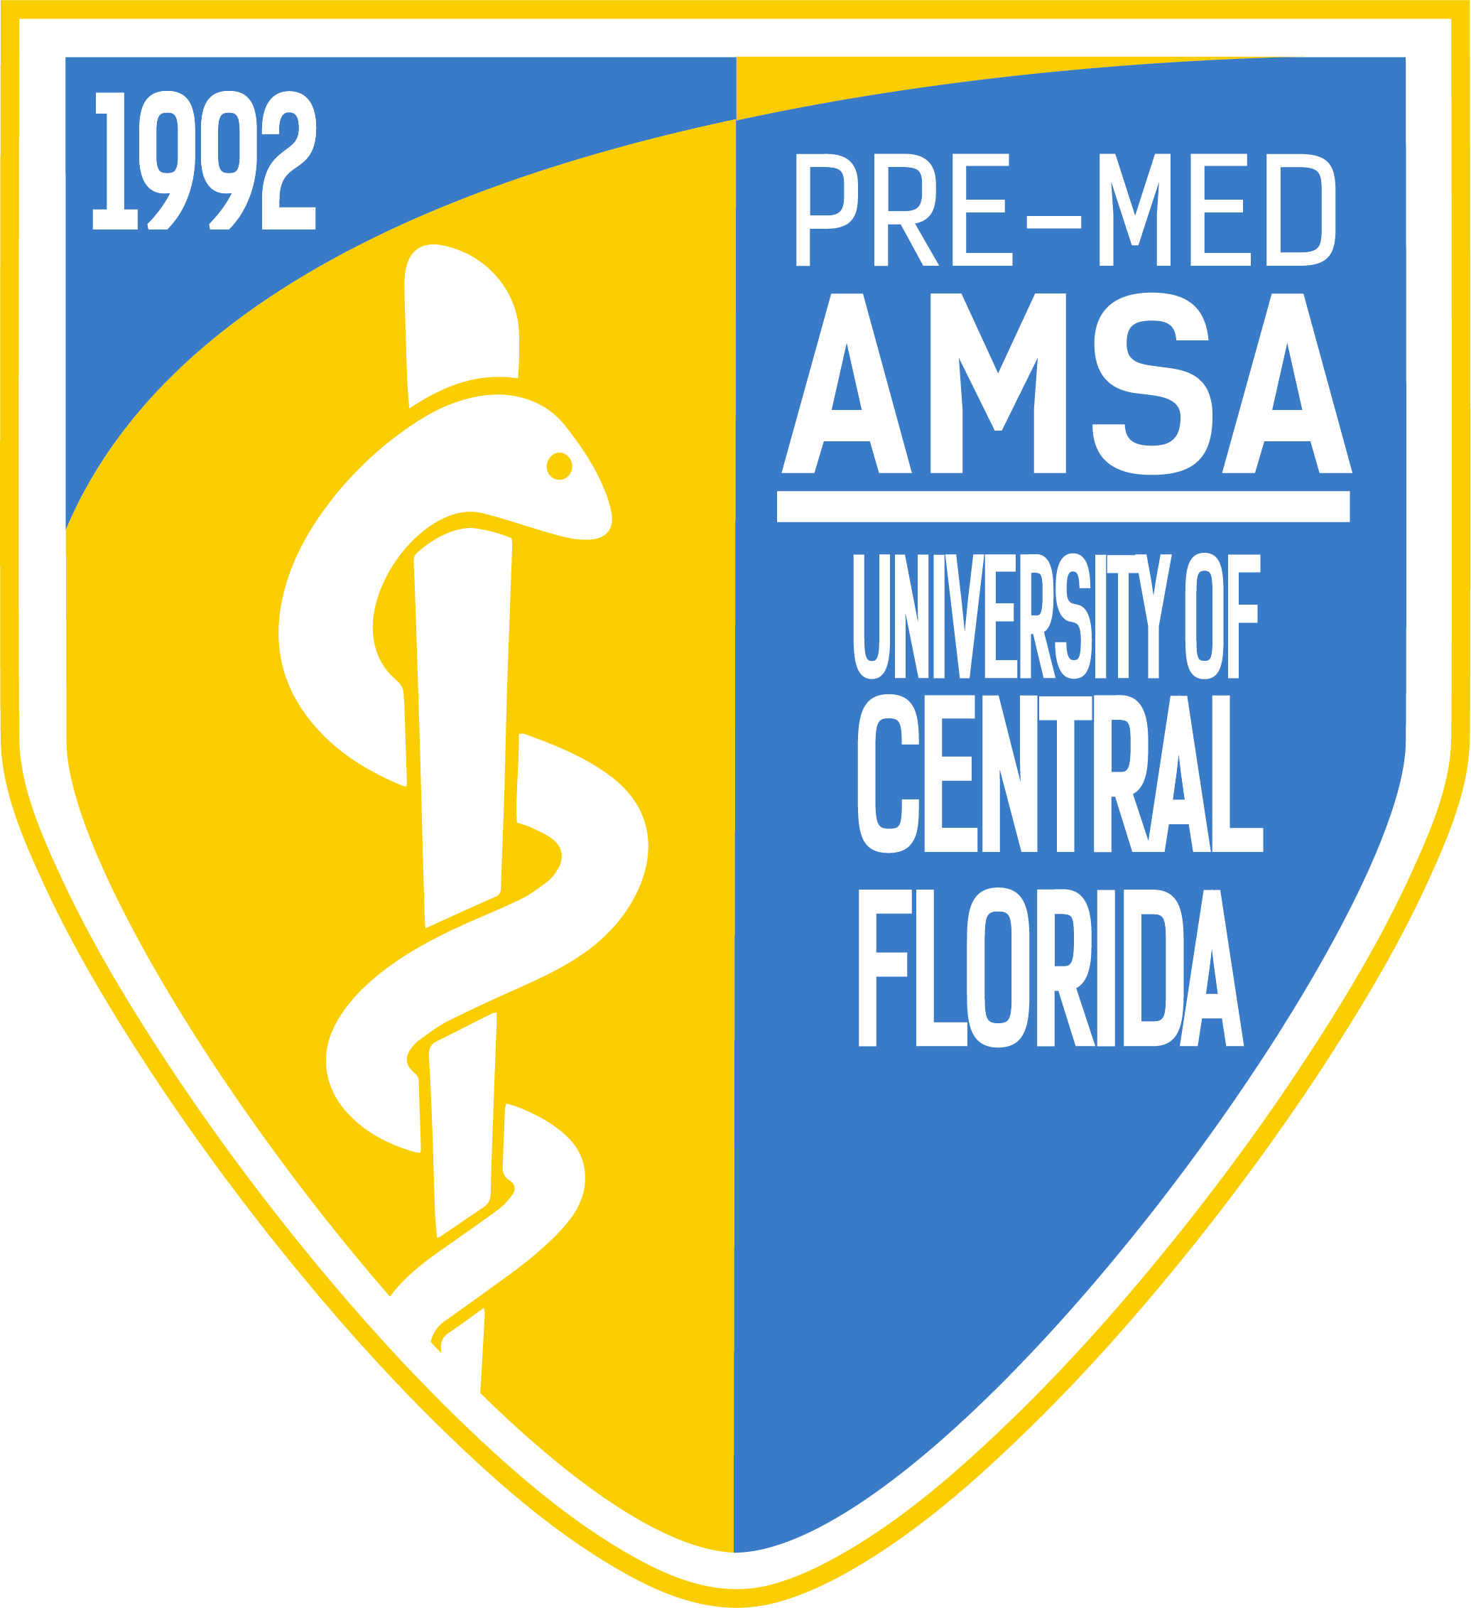
Pre-Med American Medical Student Association
Meeting Minutes
Officers: Emily Woolhiser, Salvador Corona, Anishaa Sivakumar, Taylor Duffy, Sophia Dias, Ariel Perry-Mills
Meeting Date: Tuesday, November 6th, 2018

I. Topics of Discussion
1. Executive Board discusses the variety of upcoming events, opportunities, and announcements being offered by AMSA
2. Pre-Med AMSA announces our Directorship and Member of the Month! Congratulations Justin Britton, Kyle Fowler, and Lesly Corona!
3. Dr. Gideon J. Lewis, our featured speaker, discusses his journey to becoming a physician, the importance of developing meaningful relationships, and the mindset needed to be accepted in medical school and become successful inside and outside the field of medicine.
4.. Raffle!
II. Executive Board discusses the variety of upcoming events, opportunities, and announcements being offered by AMSA.
Emily Woolhiser (President)
- Directors
  - Operations
    - Distinguished Member Pins!
      - We have just been shipped our pins for those that achieve Distinguished Member status this semester! In order to achieve this status, one must attain at least 50 AMSA points! We will be honoring our distinguished members with these pins, a certificate, and a special event only open to these committed members! There’s still time to attain 50 AMSA at the variety of events that will be occurring throughout the next handful of weeks. You can keep up with your AMSA Point-Total on our website, www.premedamsa.com.
    - West Virginia School of Osteopathic Medicine (11/7)
      - The West Virginia School of Osteophathic Medicine, one of the top D.O. programs in the country, will be presenting their program at the Nicholson School of Communication on 11/7 at 5:00 PM. 4 AMSA points will be given to those who attend.
    - Making Strides for Breast Cancer T-Shirts
      - Our “Making Strides for Breast Cancer T-Shirts”, created for our October Committee benefiting the American Breast Cancer Association, are still available to purchase! Please contact president@premedamsa.com if you are interested! Our Meeting PowerPoints, posted on our website, include a picture of the shirt. As always, all proceeds will benefit the American Breast Cancer Association, supporting the 1 in 8 females that are diagnosed with breast cancer each year.
    - November Committee
      - Our November Committee will be highlighting the HIV/AIDS epidemic, leading up to AIDS Awareness Day on December 1st!
        - If you are interested in becoming a member of our AIDS Awareness Committee, a great leadership opportunity, please contact Emily at president@premedamsa.com
    - UCF Medical School Admission Symposium
      - The 12th annual UCF Medical School Admission Symposium has officially been confirmed for February 16th, 2019 8:00 AM at the UCF College of Medicine. This is one of the biggest Pre-Med events of the year in the state of Florida. We encourage all members to visit www.ucfmsas.com to register early!
    - Pre-Med Fest
      - Thank you to everyone who attended the inaugural AMSA Pre-Med Fest hosted by the University of Central Florida this weekend! This event was a great opportunity for our members to attend a variety of breakout sessions all focused on different aspects of medicine, whether it be clinical skills workshops, MCAT prep, non-verbal communication as a physician, Medical Student panels, the list goes on! If you couldn’t make it this year, we hope you have the opportunity to attend next year!
    - AMSA National Convention
      - If you had any interest in Pre-Med Fest, we highly encourage you to look into our biggest event of the year, AMSA National Convention! This event, which is held in Washington, DC., includes a variety of Key Note speakers, events, information sessions, and interactive events all set up by National AMSA for medical students and pre-med students. This event is often a life-changing experience for those who attend and we encourage everyone to do their research and interview for a spot on the trip if interested. To interview for the trip, please go to our website, www.premedamsa.com, and click on “Forms”. You will then click on “AMSA Convention” to book an interview slot. If you have any questions about convention and the interview process, please e-mail Emily at president@premedamsa.com
    - AMSA Remind 101
      - Join AMSA’s Remind 101 by texting @premedamsa to 81010 (please note that we had originally made the flyer with an incorrect number, the one above is corret!) This service will remind you, through text, of upcoming events and meetings.
    - Office Hours
      - Just a reminder that each officer has office hours throughout the week!
        - Monday: 9:00 AM – 10:00 AM Vice President
        - Monday 10:00 AM – 11:00 AM President
        - Monday 11:15 AM – 12:15 PM Chief of Staff
        - Tuesday: 3:00 PM – 4:00 PM Treasurer
        - Friday: 9:30 AM – 10:30 AM Sergeant at Arms
        - Friday: 12:00 PM – 1:00 PM Secretary

Salvador Corona (Vice President)
- Directors
  - Wellness & Student Life
  - Health Policy
  - Global Health
  - Relay for Life
      - IM Soccer
        - Join our IM Soccer Team on Wednesdays at 9:20 PM! Please e-mail wellnessandstudentlife@premedamsa.com if you’d like to join the team!
      - Warm-Up Workshop (11/15)
        - Wellness and Student Life Director, Dylan Mackey, will be hosting a comprehensive warm-up workshop at the RWC at Knights Plaza, the smaller of the two RWCs on campus, on Thursday, November 15th, from 6:00 to 7:00 PM. This event will be worth 3 AMSA points with an extra point for those that come in AMSA gear!
      - Gym Buddies GroupMe
        - Many of our members really enjoyed our recent Spinning Class held for AMSA members. Seeing this interest sparked our Wellness and Student Life Directors to create a GroupMe for AMSA Members interested in going to the gym, spin classes, dance classes, etc. If you interest in joining this GroupMe and becoming more active physically and within AMSA, please e-mail wellnessandstudentlife@premedamsa.com
      - Christmas Party
        - Stay tuned for an AMSA Christmas Party! Date and time as well as our location is currently TBD!
      - Relay for Life
        - For those interested in Relay for Life and supporting the American Cancer Society can contact our Relay for Life directors at relayforlife@premedamsa.com
Anishaa Sivakumar (Treasurer)
  - Directors
      - Fundraising
      - Dues
        - Those that would like to pay for dues before our next General Body Meeting and/or collect their AMSA shirt are encouraged to attend Anishaa’s office hours on Tuesdays between 3:00 – 4:00 PM.
      - Spectrum Fundraiser (11/1)
        - Thank you to everyone who volunteered in our recent Spectrum Fundraiser. We had a great time getting to know our members and raising almost $2,000 for AMSA!
      - Chipotle Partial Proceeds (11/12)
        - Check out our social media or website for our Chipotle Partial Proceeds Flyer! Show this flyer at the register on November 12th to receive 3 AMSA Points w/ proof of purchase!
      - AMSA Merch
        - AMSA continues to sell Sweatshirts, Baseball Caps, and vintage AMSA T-shirts from past years! These can be purchased through our website premedamsa.com or in-person at General Body Meetings!
- Taylor Duffy (Secretary)
  - Directors
    - Mentorship
    - Academics
    - Career Development
      - Orthopedic & Sports Medicine Physician Expert Forum
        - Thank you to everyone who signed the Orthopedic & Sports Medicine Physician Expert Forum Interest Form, an event hosted by The Orthopedic and Sports Medicine Interest Group at the UCF College of Medicine. As a member of the Executive Committee, I will be personally e-mailing everyone more details about how to attend the event! Please e-mail me at taylorduffy@knights.ucf.edu if you have any questions/interest in the event!
      - Mentorship Program
        - We are still accepting applications to become a mentor or mentee in the largest Pre-Health Mentorship Program on campus! To apply, go to the “Forms” tab on our website, and click “Mentorship Form”. We currently have 70+ in the program and are always accepting new mentors/mentees! Please e-mail mentorship@premedamsa.com if you any questions/interest!
      - Q&A Panel Hosted by Mentorship (11/19)
        - Our Mentorship Directors will be hosting a Q&A Panel of 6 experienced and well-rounded members, answering questions about everything from how to get involved in research, volunteering, MCAT, leadership, academics, you name it! The event will take place in Engineering 2 (ENG2) Room 102 on Monday, November 19th, from 7:30 PM to 8:30 PM. This event will also include FREE Pizza as well as 3 AMSA Points for those attending! Please RSVP through KnightConnect if you would like to attend!
      - Pups w/ the Pre-Meds
        - Thank you to everyone who attended our recent Pups w/ the Pre-Meds event! It was a beautiful day to take a break from studying and get outside to interact with our many AMSA pups!
      - Hot Cocoa w/ crAMSA! (11/8)
        - Join our Academics Team THIS Thursday from 5:00 – 7:00 PM in The Princeton Review for a study session including Hot Cocoa and marshmallows! In addition, our academic directors will be there to answer any questions you may have with your courses/schedule, anything related to academics! This event is worth 3 AMSA Points with an extra point for those who come in AMSA Gear! Make sure you RSVP through KnightConnect!
      - Stress Relief Workshop (11/15)
        - One of our greatest events each semester, our Academics will be holding a Stress Relief Workshop at The Princeton Review on Thursday, November 15th, from 4:00 PM to 6:00 PM. This event will include a variety of activities geared to decreasing stress, whether it be crafts, drawing, glitter jar-making, and mindful thinking. Please RSVP through KnightConnect as there are limited spots available! This event will be worth 3 AMSA points w/ an extra point if you come in AMSA Gear!
      - CPR/AED Certification Course
        - Our Career Development Team has worked hard to set-up a CPR/AED Certification Course on Friday, November 16th from 1 PM to 4 PM. This course will held at the Recreation and Wellness Center and conducted by the American Red Cross. The event will ost $20 and open to only 14 paid members. Please e-mail careerdevelopment@premedamsa.com if you have any questions! This event will be worth 5 AMSA Points with an extra point if you come in AMSA Gear!
Sophia Dias (Sergeant at Arms)
  - Directors
    - Knight-Thon
    - Medical Relations
    - Volunteering
      - Chipotle Partial Proceeds
        - Thank you to everyone who came to our Chipotle Partial Proceeds following the General Body Meeting. It was great to see so many members getting to know one another after the event with Chipotle burritos and bowls, all supporting AMSA’s Knight-Thon Team!
      - Volunteering Events this October!
        - 11/11: VA Memorial Service
          - 10:00 AM – 12:00 PM
        - 11/12: Brighter Lipstick, Bigger Earrings
          - 6:00 PM – 8:00 PM
        - 11/15 Camp Boggy Creek Application Opens
          - Please go to our website, www.premedamsa.com and go under “Forms”. There will then be a “Campy Boggy Creek 2018 Holiday Party” Form
        - 11/3: BASE Camp Babysitting Night
          - Any questions about each of these great volunteering events can contact volunteering@premedamsa.com! Each event will be worth 3 AMSA Points with an extra point given to those who attend in AMSA Gear! As always, RSVP for these events through our KnightConnect page.
        - For a Day, Family Day Fundraiser & BASE Camp Babysitting Night!
          - Thank you to everyone who attended each of these events. Members had a great time supporting two great causes!
        - General Rules for Volunteering Events
          - All volunteering events are open to PAID Members ONLY!
            - Accountability: If you RSVP for an event, we expect you to stay for the entire event, unless otherwise specified.
            - Professionalism: When you are at events, you are representing AMSA, we want to be proud of our members!
Ariel Perry-Mills (Chief of Staff)
  - Directors
    - Media Relations
    - Newsletter
    - Research
      - Upcoming Research Events!
        - Getting Started in Undergraduate Research
          - This event will take place in Trevor Colburn Hall 201, just like the event above, on November 7th from 3:30 PM to 5 PM.
          - If you have any questions about research or the events above please e-mail research@premedamsa.com
        - Find and Apply for Summer Off-Campus Research Experiences
          - This event will take place on November 14th from 3:00 to 4:00 PM in Trevor Colburn Hall 201. Please RSVP on KnightConnect to attend and grab your AMSA Points!
      - Doing Research?
        - If you are performing any research as an undergraduate here at UCF, no matter what the discipline, we want to hear about it and potentially feature you in our upcoming AMSA Newsletter! Please click the “Forms” tab on our website and fill out the Research Newsletter Feature Form to do so! Any questions related to this Newsletter Feature or research in general, please e-mail research@premedamsa.com
      - Newsletter
        - We will now be handing out modified newsletters, with the aim of reaching more members at our General Body Meetings (we can only print so many hundreds of papers!) With that said, our full editions of “The Pulse” will always be available online, under “Media” before each General Body Meeting!
      - MCAT Question of the Day
        - Our MCAT Question of the Day will now be performed online and expire before the next General Body Meeting! This allows members more than enough time to complete the MCAT Question of the Day, while also eliminating the inevitable post-meeting rush to hand in the MCAT Question of the Day to our Chief of Staff, Ariel.
III. Directorship and Member of the Month
- Directorship of the Month
  - Congratulations to Justin Britton and Kyle Fowler, our Mentorship Directors, for winning Directorship of the Month. Justin and Kyle have gone above and beyond to grow the Mentorship Program into 70+ members with a very organized point system, mentor/mentees check-in process, along with the many events and opportunities they put together for mentors and mentees. Thank you Justin and Kyle for all you do for AMSA!
- Member of the Month
  - Congratulations to Lesly Corona, our Member of the Month! Lesly currently has the most AMSA Points of the entire organization! She has been extremely committed to AMSA, attending a variety of events and being very involved as a member of AMSA’s Knight-Thon Team. Thank you Lesly for being such an enthusiastic and active member!

IV. Dr. Gideon J. Lewis
Dr. Lewis is a Board Certified Foot and Ankle Surgeon, specializing in high-performance sports medicine. In addition to his accolades as a surgeon, Dr. Lewis is also extremely involved within the UCF community, serving as a faculty member for the UCF College of Medicine, founder and director of the UCF Surgical Internship, Faculty Advisor for the UCF COM Orthopedic and Sports Medicine Interest Group (OSMIG), and member of the Board of Directors for the UCF Foundation.
During his talk, Dr. Lewis’ discussed his own journey throughout high school, his time as an undergraduate at UCF, his journey through medical school, and his experience as a high performance sports medicine physician. While Dr. Lewis explained that he was rarely the most gifted student in his classes, he emphasized the fact that once he found his passion, he wouldn’t let anyone outwork him. A relentless work ethic is the foundation for success within any competitive field..
In addition to the importance of work ethic, Dr. Lewis stressed the importance of developing relationships throughout your life. These relationships are worth more than any monetary amount, and will grant you opportunities that money could never buy. While discussing this topic, Dr. Lewis had us perform an exercise in which we closed our eyes and visualized the closest friend we’ve made at UCF. He then asked us if we would completely sell that relationship for $100,000. After attaining feedback from our members, each member expressed that they would not sell their best friend at UCF for $100,00, displaying the high value that these friendships had within our lives. He explained that you can apply this mindset with all of your relationships, to ultimately understand just how valuable relationships and connections truly are. As you build up your network and place effort in your relationships, you can begin developing million-dollar relationships that are invaluable within any professional field.
Also accompanying Dr. Lewis at the meeting was Valerie Cacciatore, current medical student at Rocky Vista University College of Osteopathic Medicine and former Surgical Intern under Dr. Lewis. As a medical student currently traveling to interviews for OB/GYN residencies, Valerie provided us with another perspective in regards to medical school interviews as well as the other aforementioned topics brought about by Dr. Lewis.
We cannot thank Dr. Lewis and Valerie for creating time in their busy schedules to not only be our featured speakers for this meeting, but also spend a significant amount of time after the completion of the meeting to answer the many individual questions that our members had prepared for them.

VI. Raffle
1. Pre-Med AMSA Raffled off a Starbucks Gift Card, vintage AMSA t-shirt, AMSA Baseball Hat, an AMSA binder, TPR Medical School Guide, and an AMSA Water Bottle.
In addition to AMSA’s raffle, Dr. Lewis was also generous enough to offer 6 more raffle prizes of his own! He awarded 6 raffled students a complete reimbursement of their membership dues! Congratulations to the 6 members who now have their National AMSA and local chapter dues completely paid off! We will be contacting you soon through e-mail to provide you with Dr. Lewis’ gift! We have never had a speaker join in on our raffle and in such a generous manner!
VII. Roundtable w/ the Executive Board, Dr. Lewis, and Valeria Cacciatore.

