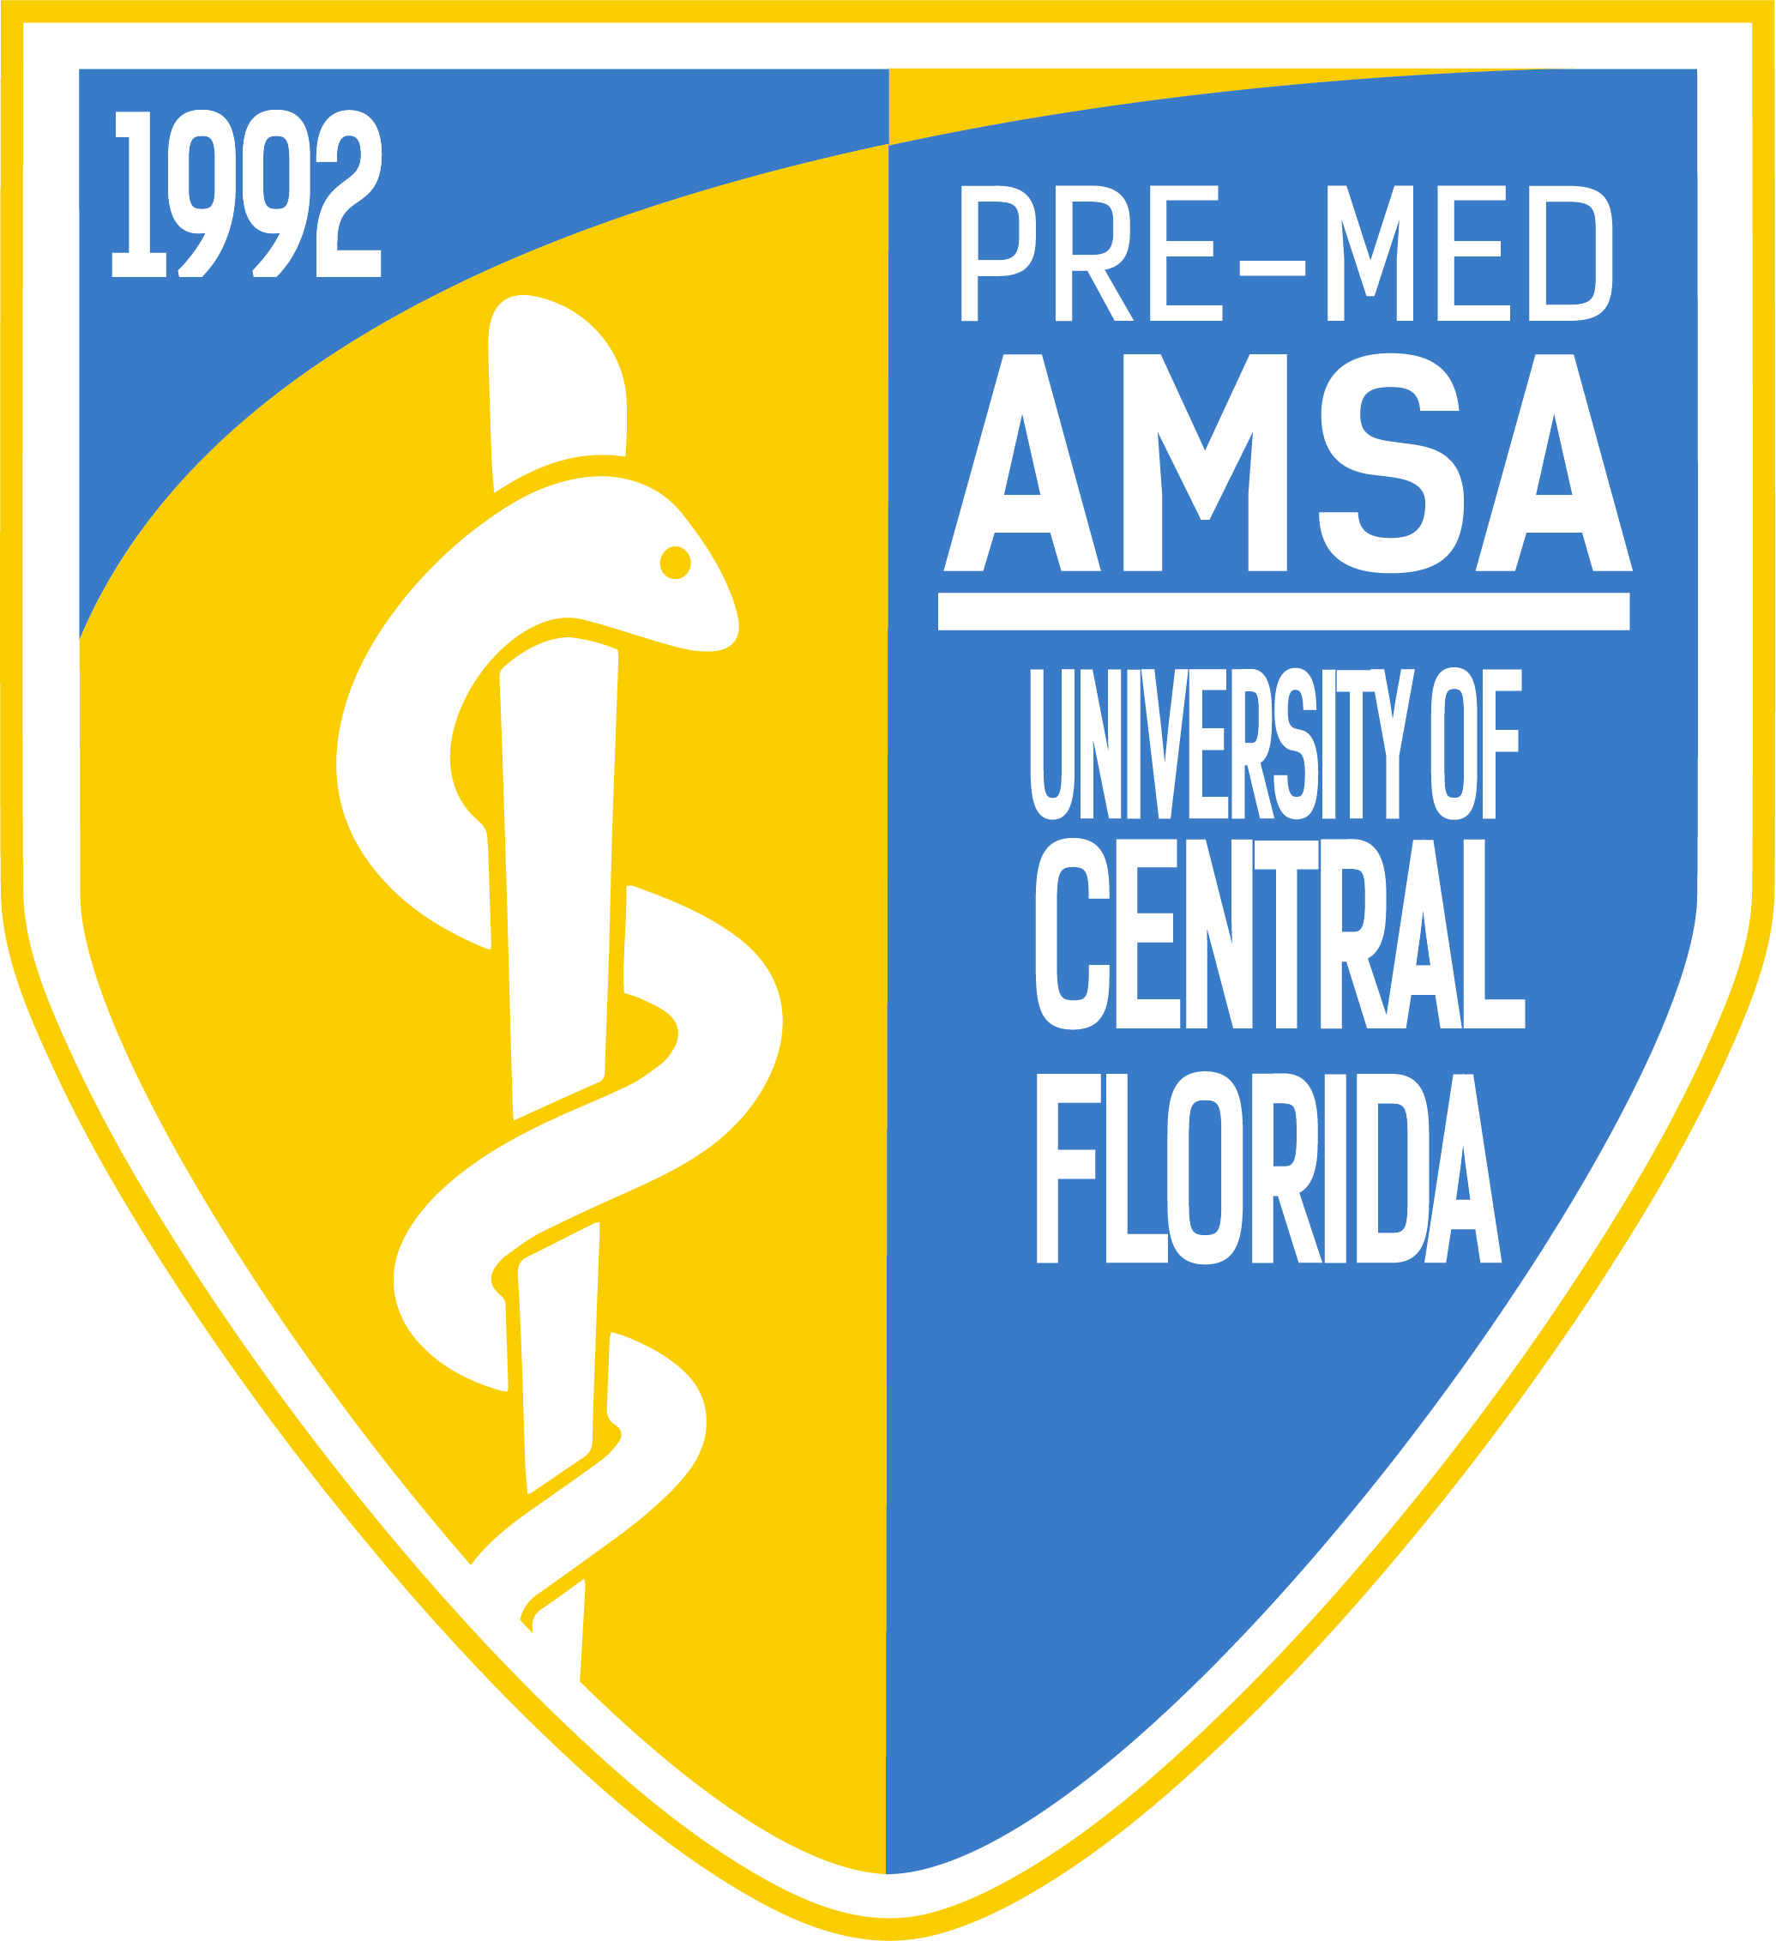
Pre-Med American Medical Student Association
Meeting Minutes
Officers: Emily Woolhiser, Salvador Corona, Anishaa Sivakumar, Taylor Duffy, Sophia Dias, Ariel Perry-Mills
Meeting Date: Tuesday, November 27th, 2018

I. Topics of Discussion
1. Executive Board discusses the variety of upcoming events, opportunities, and announcements being offered by AMSA
2. Pre-Med AMSA announces our Directorship and Member of the Month! Congratulations Reetish Singla, Anna Jurlina, and Riya Shah.
3. Dr. Trevor Persaud, our featured speaker and former Pre-Med AMSA President, discusses his time as a pre-med at UCF, his journey to becoming a resident physician, and the field of Physical Medicine and Rehabilitation.
4. Townhall-style discussion
4.. Raffle!
II.
Emily Woolhiser (President)
- Directors
  - Operations
    - Directorship Spots Open!
      - Due to a small number of directors graduating in the Spring, we will be having a limited number of spots open for directorships within AMSA’s Leadership Team. Those interested in taking on a leadership role within AMSA and interviewing for such directorships are encouraged to e-mail Emily at president@premedamsa.com.
    - Pre-Med AMSA Blood Drive (11/28)
      - November 28th, 9:00 AM to 7:00 PM at Veterans Commemorative Site right by Memory Mall!
        - AMSA will be tabling the above event from 10:00 AM to 3:00 PM in partnership with UCF Blood Drives.
    - AMSA Holiday Party (11/30)
      - AMSA will be holding a holiday party this Friday, November 30th, from 7:00 PM to 9:00 PM at the Knights Circle Phase 2 Clubhouse. This holiday-themed holiday party will celebrate our great semester and even greater members. Distinguished members will be honored along with a Secret Santa reveal for those that had previous signed up for such. Those attending are encouraged to dress up in their ugly sweaters or any other holiday-themed gear! Any questions or carpooling interest should email president@premedamsa.com.
    - AMSA Remind 101
      - Join AMSA’s Remind 101 by texting @premedamsa to 81010 This service will remind you, through text, of upcoming events and meetings.
    - November Directorship and Member of the Month
      - Congratulations to our Operations directors, Anna Jurlina, Riya Shah, and Reetish Singla, for being awarded our Directorship of the Month! These directors have been committed each and every week to keeping our organization running smoothly, publicly as well as behind-the-scenes. We truly appreciate everything they bring to AMSA!
      - Congratulations to Austin Eason, our Member of the Month. Austin has been one of our most active members this given semester and has always made the extra effort to get to know others in the organization and bring more involvement within AMSA. He is especially popular at our AMSA-hosted BASE Camp volunteering events, where he has made lasting connections with pediatric cancer patients.
    - Executive Board Office Hours
      - Just a reminder that each officer has office hours throughout the week!
        - Monday: 9:00 AM – 10:00 AM Vice President
        - Monday 10:00 AM – 11:00 AM President
        - Monday 11:15 AM – 12:15 PM Chief of Staff
        - Tuesday: 3:00 PM – 4:00 PM Treasurer
        - Friday: 9:30 AM – 10:30 AM Sergeant at Arms
        - Friday: 12:00 PM – 1:00 PM Secretary

Salvador Corona (Vice President)
- Directors
  - Wellness & Student Life
  - Health Policy
  - Global Health
  - Relay for Life
      - IM Soccer
        - Join our IM Soccer Team on Wednesdays at 9:20 PM! Please e-mail wellnessandstudentlife@premedamsa.com if you’d like to join the team!
      - Relay for Life Bake Sale and Chipotle Partial Proceeds
        - Our Relay for Life directors will be holding a Bake Sale and Chipotle Partial Proceeds on 12/4 to support the American Cancer Society. AMSA Points will be provided to those who attend the Chipotle Partial Proceeds and/or table or donate to their Bake Sale! E-mail relayforlife@premedamsa.com if you have any questions about joining the AMSA Relay for Life Team or about any of these fundraising events!
    - UCF Medical School Admission Symposium
      - The 12th annual UCF Medical School Admission Symposium has officially been confirmed for February 16th, 2019 8:00 AM at the UCF College of Medicine. This is one of the biggest Pre-Med events of the year in the state of Florida. We encourage all members to visit www.ucfmsas.com to register early!
Anishaa Sivakumar (Treasurer)
  - Directors
      - Fundraising
      - Dues
        - Those that would like to pay for dues before our next General Body Meeting and/or collect their AMSA shirt are encouraged to attend Anishaa’s office hours on Tuesdays between 3:00 – 4:00 PM.
      - Movie Knight with fAMSA
        - Thank you to everyone who attended our recent showing of Elf at Movie Knight!
      - New Sponsors!
        - We’d like to thank NextStep Test Prep and Viva Wireless, two of our new sponsors to this upcoming school year, for their commitment towards support Pre-Med AMSA and our mission as an organization. We are extremely thankful for their support!
      - New AMSA Hoodies!
        - AMSA continues to sell Sweatshirts, Baseball Caps, and vintage AMSA T-shirts from past years, but now we have a new merch item to add to the mix! AMSA now has hoodies! Pictures of the hoodie can be found on our website or within our recent Meeting Powerpoints, also found within our website. These hoodies will be $30, with all proceeds going straight to AMSA. They can be purchased through our website premedamsa.com or in-person at General Body Meetings! Please contact Anishaa at treasurer@premedamsa.com if you have any interest in purchasing a hoodie or one of our many other items!
- Taylor Duffy (Secretary)
  - Directors
    - Mentorship
    - Academics
    - Career Development
      - Thank You!
        - Thank you to each and every one of our members who attended one or more of the most recent events hosted by our Academics, Career Development, and Mentorship directors. Our CPR/AED Certification Course, Stress Relief Workshop, and Q&A Panel were all major hits among those who attended!
      - Mentorship Program
        - We are still accepting applications to become a mentor or mentee in the largest Pre-Health Mentorship Program on campus! To apply, go to the “Forms” tab on our website, and click “Mentorship Form”. We currently have 75+ in the program and are always accepting new mentors/mentees! Please e-mail mentorship@premedamsa.com if you any questions/interest!
      - Mentorship T-Shirts
        - Those within the Pre-Med AMSA Mentorship Program will now have the opportunity to purchase AMSA’s very first pocket-tee! This T-Shirt will be on sale within the next coming week or two. Pre-Orders are currently being organized within the Mentorship Program Facebook page. If you are a mentor or mentee within the program and have not joined the Facebook Group please do so!
Sophia Dias (Sergeant at Arms)
  - Directors
    - Knight-Thon
    - Medical Relations
    - Volunteering
      - Camp Boggy Creek’s Christmas Party! (12/8)
        - Join AMSA at Camp Boggy Creek’s Christmas Party on Saturday, December 8th, from 8:00 AM to 5:00 PM
          - Location: 30500 Brantley Branch Rd, Eustis, FL 32736
      - Veteran’s Day Memorial & Brighter Lipstick, Bigger Earrings
        - Thank to everyone who attended our recent Veteran’s Day Memorial and Brighter Lipstick, Bigger Earrings events!
      - AMSA Knight-Thon Team
        - We are still accepting new members to join our AMSA Knight-Thon Team! Please e-mail sergeantatarms@premedamsa.com or knightthon@premedamsa.com if you are interested in being a part of such an amazing event and team!
      - The Thank You Project
        - Check out Arnold Palmer Hospital’s The Thank You Prokect video to learn more about the impact Arnold Palmer can have on a given family and why we at AMSA feel so passionate about Knight-Thon
          - Link to video: https://www.youtube.com/watch?v=SwKyauE_l-k
Ariel Perry-Mills (Chief of Staff)
  - Directors
    - Media Relations
    - Newsletter
    - Research
      - AMSA Points & Distinguished Members
        - With the semester winding down, please e-mail any AMSA Point discrepancies/questions to Ariel at chiefofstaff@premedamsa.com! We want all members to have the most up-to-date and accurate points, especially those inching closer to the 50-point threshold that gets them to Distinguished Member status!
      - Doing Research?
        - If you are performing any research as an undergraduate here at UCF, no matter what the discipline, we want to hear about it and potentially feature you in our upcoming AMSA Newsletter! Please click the “Forms” tab on our website and fill out the Research Newsletter Feature Form to do so! Any questions related to this Newsletter Feature or research in general, please e-mail research@premedamsa.com
      - Newsletter
        - We will now be handing out modified newsletters, with the aim of reaching more members at our General Body Meetings (we can only print so many hundreds of papers!) With that said, our full editions of “The Pulse” will always be available online, under “Media” before each General Body Meeting!
      - MCAT Question of the Day
        - Our MCAT Question of the Day will now be performed online and expire before the next General Body Meeting! This allows members more than enough time to complete the MCAT Question of the Day, while also eliminating the inevitable post-meeting rush to hand in the MCAT Question of the Day to our Chief of Staff, Ariel.
IV. Dr. Trevor Persaud
Dr. Trevor Persaud is a former Pre-Med AMSA President and UCF alum and current resident in Miami, FL, specializing in Physical Medicine and Rehabilitation.
Dr. Persaud began the meeting by discussing his own personal journey at UCF, inside and outside of the classroom. He emphasized the importance of seemingly little things, such as one’s involvement in AMSA, and how these are often the type of things that come up in medical school interviews. He encouraged us to stay active outside of classes, taking advantage of the many resources and opportunities offered at UCF. While one’s student-life should be balanced, Dr. Persaud stressed the fact that one must be able to make sacrifices as a pre-med and that these sacrifices will only grow as one enters medical school.
In medical school Dr. Persaud described the importance of building a foundation with much of the knowledge we are offered as undergraduates. While it’s easy to brush off certain topics/subject matter that we are taught as undergraduates, medical schools will expect you to understand this foundational information. Taking the time to truly learn this material will pay great dividends in medical school.
Dr. Persaud closed his speaking engagement by discussing, in detail, the field of Physical Medicine and Rehabilitation. He then answered a variety of questions from our members, from pre-med related questions, to questions about his own specialty.
V. Townhall-style Discussion
Following the conclusion of our featured speaker, Executive Board members held a townhall-style discussion where we sought feedback on how we could improve as an organization moving forward. Some topics/feedback discussed are outlined below:
- Increasing number of social events
- More consistency with social media posts
- Facilitated study groups for those enrolled in the same courses
- Reminder texts not only for General Body Meetings, but also other events, especially those that are not advertised at the meeting
- Having directors communicate further with General Body during meetings, especially when discussing events that they have taken the lead on.
- Having directors and active members move outside of their own friendship circles/comfort zones and making the effort to sit and get to know our other members of AMSA!
Speaking on behalf of the Executive Board, we will do our very best to incorporate the feedback we received during this townhall-style discussion! We appreciate everyone who participated and encourage those that could not to fill out our Member Feedback Form on https://www.premedamsa.com/new-page-2/.

VI. Raffle
1. Pre-Med AMSA Raffled off a Starbucks Gift Card, two vintage AMSA t-shirt, an AMSA Water Bottle, and an AMSA sweatshirt.
VII. Roundtable w/ the Executive Board and Dr. Persaud

