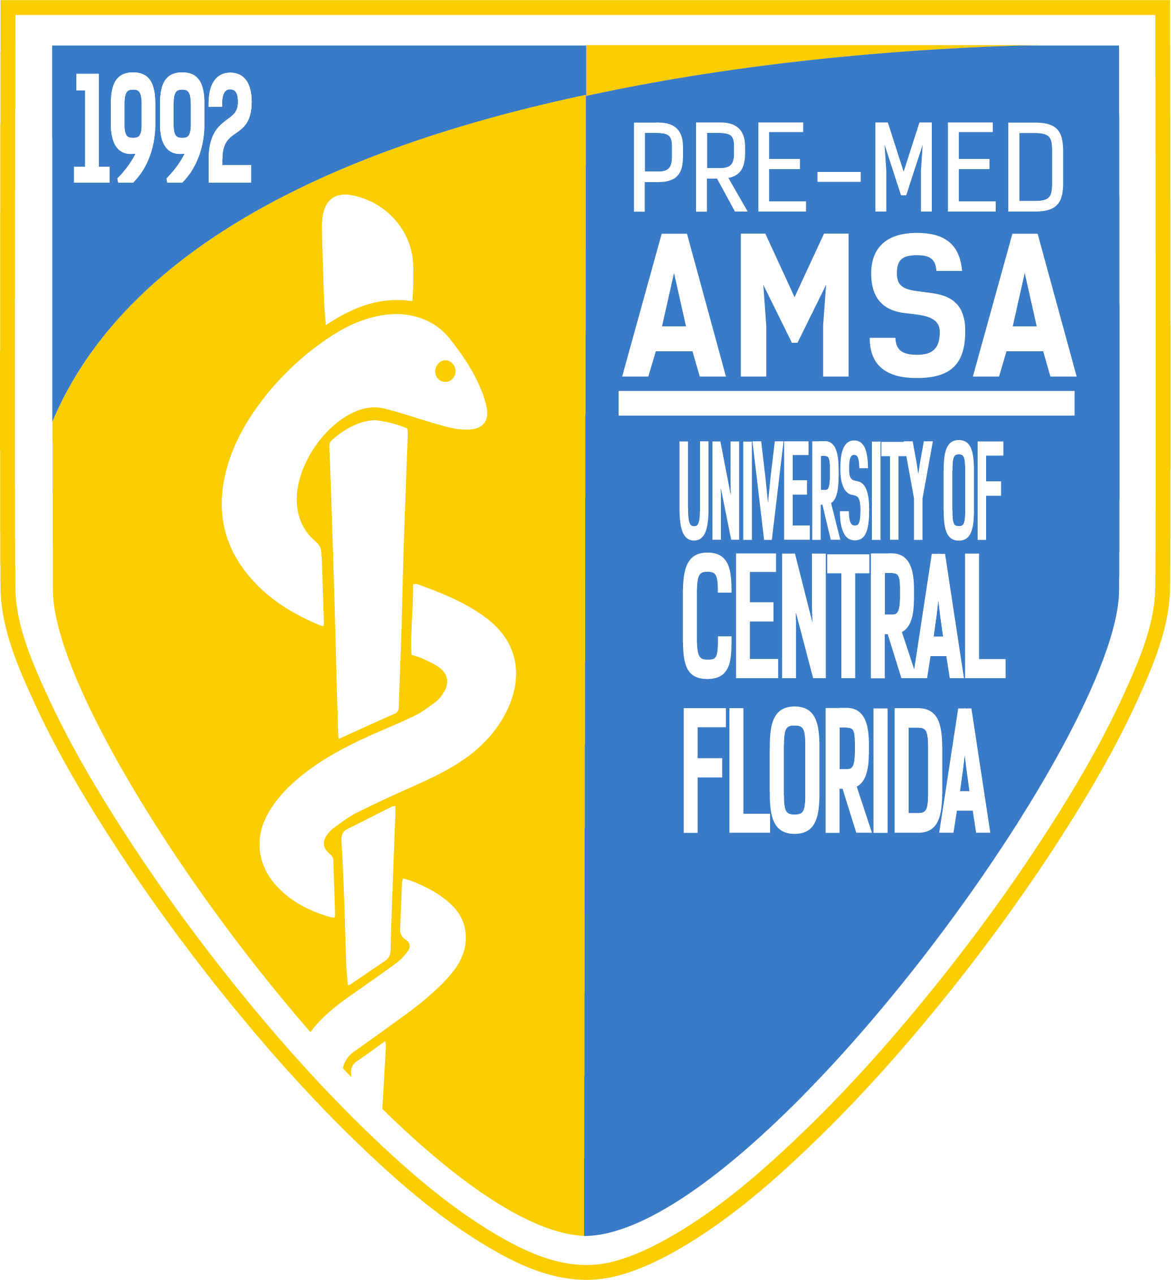
Pre-Med American Medical Student Association
Meeting Minutes
Officers: Emily Woolhiser, Salvador Corona, Anishaa Sivakumar, Taylor Duffy, Sophia Dias, Ariel Perry-Mills
Meeting Date: Tuesday, January 15th, 2019

I. Topics of Discussion
1. The Princeton Review speaks on their services and MCAT courses
2. Pre-Med AMSA faculty advisor, Dr. Erin Myszkowski, speaks on AMSA and the services provided by the Pre-Health and Pre-Law (PHPL) Office.
3. Executive Board discusses the variety of upcoming events, opportunities, and announcements being offered by AMSA
4. Pre-Med AMSA announces our Directorship and Member of the Month! Congratulations to Juliet Cahow, Lily Tehrani, and Stephanie Coutinho!
5. Jake Sambursky, former Pre-Med AMSA Executive Board member and current M4 at the UCF College of Medicine, presents a comprehensive guide to being accepted into medical school, from the beginning of one’s undergraduate journey to the entire medical school application process.
6. Raffle!
II.
Emily Woolhiser (President)
- Directors
  - Operations
    - Emily’s Spring 2019 Office Hours Tuesday 10:30 AM – 11:30 AM
    - Operations Office Hours
      - Reetish Monday 9:00 AM – 10:00 AM
      - Anna Friday 1:00 PM to 1:50 PM
      - Riya Friday 10:30 AM – 11:30 AM
    - January Committee
        - Mental Health Awareness
          - Anyone interested in joining this January’s committee, a great leadership opportunity, please e-mail Emily at president@premedamsa.com
    - Out of the Darkness Walk
      - February 2nd 2019, 8:00 AM
      - Location: 2420 Lakemont Ave, Baldwin Park, FL 32814
      - The Out of the Darkness Walk benefits the American Foundation for Suicide Prevention by raising awareness of suicide and depression while also raising money for research and education to support their mission of preventing suicide within our nation.
        - AMSA Points: 4, +1 w/ AMSA Shirt
    - AMSA Long Sleeves are available for purchase!
      - Please visit out “Shop” on our website, www.premedamsa.com, if you’d like to purchase our latest AMSA Long Sleeve.
        - Price: $20
    - UCF Medical School Admission Symposium
      - The 12th annual UCF Medical School Admission Symposium has officially been confirmed for February 16th, 2019 8:00 AM at the UCF College of Medicine. This is one of the biggest Pre-Med events of the year in the state of Florida. We encourage all members to visit www.ucfmsas.com to register!
    - AMSA Remind 101
      - Join AMSA’s Remind 101 by texting @premedamsa to 81010 This service will remind you, through text, of upcoming events and meetings.
    - January Directorship and Member of the Month
      - Congratulations to our Newsletter directors, Juliet Cahow and Lily Tehrani, for being awarded our Directorship of the Month! These directors have been committed each and every week to create the best newsletters our organization has ever had! We truly appreciate the effort and creativity they provide, as well as the informative content they provide all of our members.
      - Congratulations to Stephanie Coutinho, our Member of the Month. Stephanie has been one of our most active members this given semester and has always made the extra effort to get to know others in the organization and bring more involvement within AMSA. She is currently a mentee in our Mentorship Program and well on her way to being an amazing mentor in the future!
Salvador Corona (Vice President)
- Directors
  - Wellness & Student Life
  - Health Policy
  - Global Health
  - Relay for Life
      - Salvador’s Spring 2019 Office Hours Tuesday: 12:00 PM to 1:00 PM
      - IM Soccer
        - Join our IM Soccer Team on Wednesdays at 9:20 PM! Please e-mail wellnessandstudentlife@premedamsa.com if you’d like to join the team!
      - FIFA Tournament Fundraiser!
        - February 1st, 6:00 PM to 8:00 PM
        - Location: Student Union Sand Key Room 220
          - AMSA Points: 3 Points, +1 w/AMSA gear
        - To sign up for the tournament, please visit https://www.premedamsa.com/fifa-tournament/
Anishaa Sivakumar (Treasurer)
  - Directors
      - Fundraising
      - Dues
        - Those that would like to pay for dues before our next General Body Meeting and/or collect their AMSA shirt are encouraged to attend Anishaa’s office hours on Tuesdays between 3:00 – 4:00 PM.
      - NextStep MCAT Courses Available!
        - If you are interested in purchasing a special AMSA-discounted MCAT course from NextStep Prep Courses, please e-mail Anishaa at treasurer@premedamsa.com.

      - New AMSA Long Sleeves and Hoodies!
        - AMSA continues to sell Sweatshirts, Baseball Caps, and vintage AMSA T-shirts from past years, we now have two new items to added to our shop! AMSA now has long sleeves and hoodies! Pictures of these items can be found on our website or within our recent Meeting Powerpoints, also found within our website. The hoodies will be $30 and the long sleeves $20. All proceeds go right back to AMSA, funding all the awesome events and opportunities we facilitate for our members. These items can be purchased through our website, www.premedamsa.com, or in-person at General Body Meetings! Please contact Anishaa at treasurer@premedamsa.com if you have any interest in purchasing any one of these items!
Taylor Duffy (Secretary)
  - Directors
    - Mentorship
    - Academics
    - Career Development
      - E-Mail List!
        - If you are not signed up for our e-mail list, please e-mail me at secretary@premedamsa.com so I can add you to the list and do my best to better connect you with everything going on within AMSA!
      - Mentorship Program
        - We are still accepting applications to become a mentor or mentee in the largest Pre-Health Mentorship Program on campus! To apply, go to the “Forms” tab on our website, and click “Mentorship Form”. We currently have 75+ in the program and are always accepting new mentors/mentees! Please e-mail mentorship@premedamsa.com if you any questions/interest!
      - Mentorship T-Shirts
        - Those within the Pre-Med AMSA Mentorship Program will now have the opportunity to purchase AMSA’s very first pocket-tee! This T-Shirt will be on sale within the next coming week or two. Pre-Orders are currently being organized within the Mentorship Program Facebook page. If you are a mentor or mentee within the program and have not joined the Facebook Group please do so!
      - crAMSA every Monday!
        - Our academics directors will be hosting crAMSA study sessions every Monday from 5:00 PM to 6:30 PM at The Princeton Review (by the Arena and Dunkin Donuts), starting on January 28th!
          - AMSA Points: 3 Points, +1 w/ AMSA Gear
Sophia Dias (Sergeant at Arms)
  - Directors
    - Knight-Thon
    - Medical Relations
    - Volunteering
      - Volunteering Events Coming UP!
        - 1/16 Brighter Lipstick, Bigger Earings
          - 6:00 to 8:00 PM at The Princeton Review
            - 3 AMSA Points, + 1 w/ AMSA Shirt
        - 1/19 Second Harvest
          - 1:00 – 3:00 PM
            - 3 AMSA Points, +1 w/ AMSA Shirt
        - 1/24 VA Bingo Night
          - 6:00 – 7:30 PM
            - 3 AMSA Points, +1 w/ AMSA Shirt
        - 1/28 VA Card Night
          - 6:00 – 7:30 PM
            - 3 AMSA Points, +1 w/ AMSA Shirt
        - 2/2 Out of the Darkness Walk
          - 8:00 AM – 12:00 PM at BaldwinPark
            - 5 AMSA Points, + 1 w/ AMSA Shirt
        - 2/8 Night to Shine (Tim Tebow Foundation)
          - If you are interested in being a part of this great event, please visit http://www.riverrun.church/project/night-to-shine
          - Applications are due 1/27!
      - Winner of the Winter Social Media Contest
        - Congratulations to Juliet Cahow for winning our Winter Social Media Contest! Juliet posted the most creative winter-themed picture while rocking some of her AMSA Gear! Thank you to everyone for taking part in this contest!
Ariel Perry-Mills (Chief of Staff)
  - Directors
    - Media Relations
    - Newsletter
    - Research
      - Women in Surgery Career Symposium Info Session
        - January 23, 2019, 6:00 PM
        - Location: The Princeton Review
          - 3 AMSA Points, +1 w/ AMSA Shirt!
      - AMSA Points & Distinguished Members
        - With the semester winding down, please e-mail any AMSA Point discrepancies/questions to Ariel at chiefofstaff@premedamsa.com! We want all members to have the most up-to-date and accurate points, especially those inching closer to the 50-point threshold that gets them to Distinguished Member status!
      - Doing Research?
        - If you are performing any research as an undergraduate here at UCF, no matter what the discipline, we want to hear about it and potentially feature you in our upcoming AMSA Newsletter! Please click the “Forms” tab on our website and fill out the Research Newsletter Feature Form to do so! Any questions related to this Newsletter Feature or research in general, please e-mail research@premedamsa.com
      - MCAT Question of the Day
        - Our MCAT Question of the Day will now be performed online and expire before the next General Body Meeting! This allows members more than enough time to complete the MCAT Question of the Day, while also eliminating the inevitable post-meeting rush to hand in the MCAT Question of the Day to our Chief of Staff, Ariel.
IV. Jake Sambursky
Jake Sambursky is a former Pre-Med AMSA Executive Board member and currently an M4 at the UCF College of Medicine.
Jake began his presentation offering his advice on how to approach the pre-med track, from the beginning to the end. He emphasized the importance of prioritizing one’s GPA and MCAT, as those are the two things that will ultimately get you in the door of medical school admission committees. He then explained that everything else should be used a means of standing out to each school. While all pre-meds should strive to volunteer, obtain clinical experience, do research, and essentially “check off the boxes”, one must truly do what they love in order to enjoy the journey and put forth the effort required to stand out in such a rigorous selection process. Finding extracurriculars you enjoy will not only encourage you to continue on and excel in these activities, but it will also show through on ones AMCAS application, as well as in-person during interviews. In addition to Jake’s thoughts on what it takes to become the most competitive and happy of pre-meds, he also dove deep into medical school application and the statistics of those applying to medical schools around the nation, as well as the UCF College of Medicine itself.
Jake made it a point, throughout his entire presentation, to stay positive and understand that with hard work, each and every single person in the room will become a physician, and that all the hard work, all the stress… it’s all worth it. As he stated, “I would do it 100 times over”.
VI. Raffle
1. Pre-Med AMSA Raffled off two vintage AMSA t-shirt and a Pre-Med AMSA Breast Cancer Walk t-shirt.
VII. Roundtable w/ the Executive Board and Jake Sambursky

