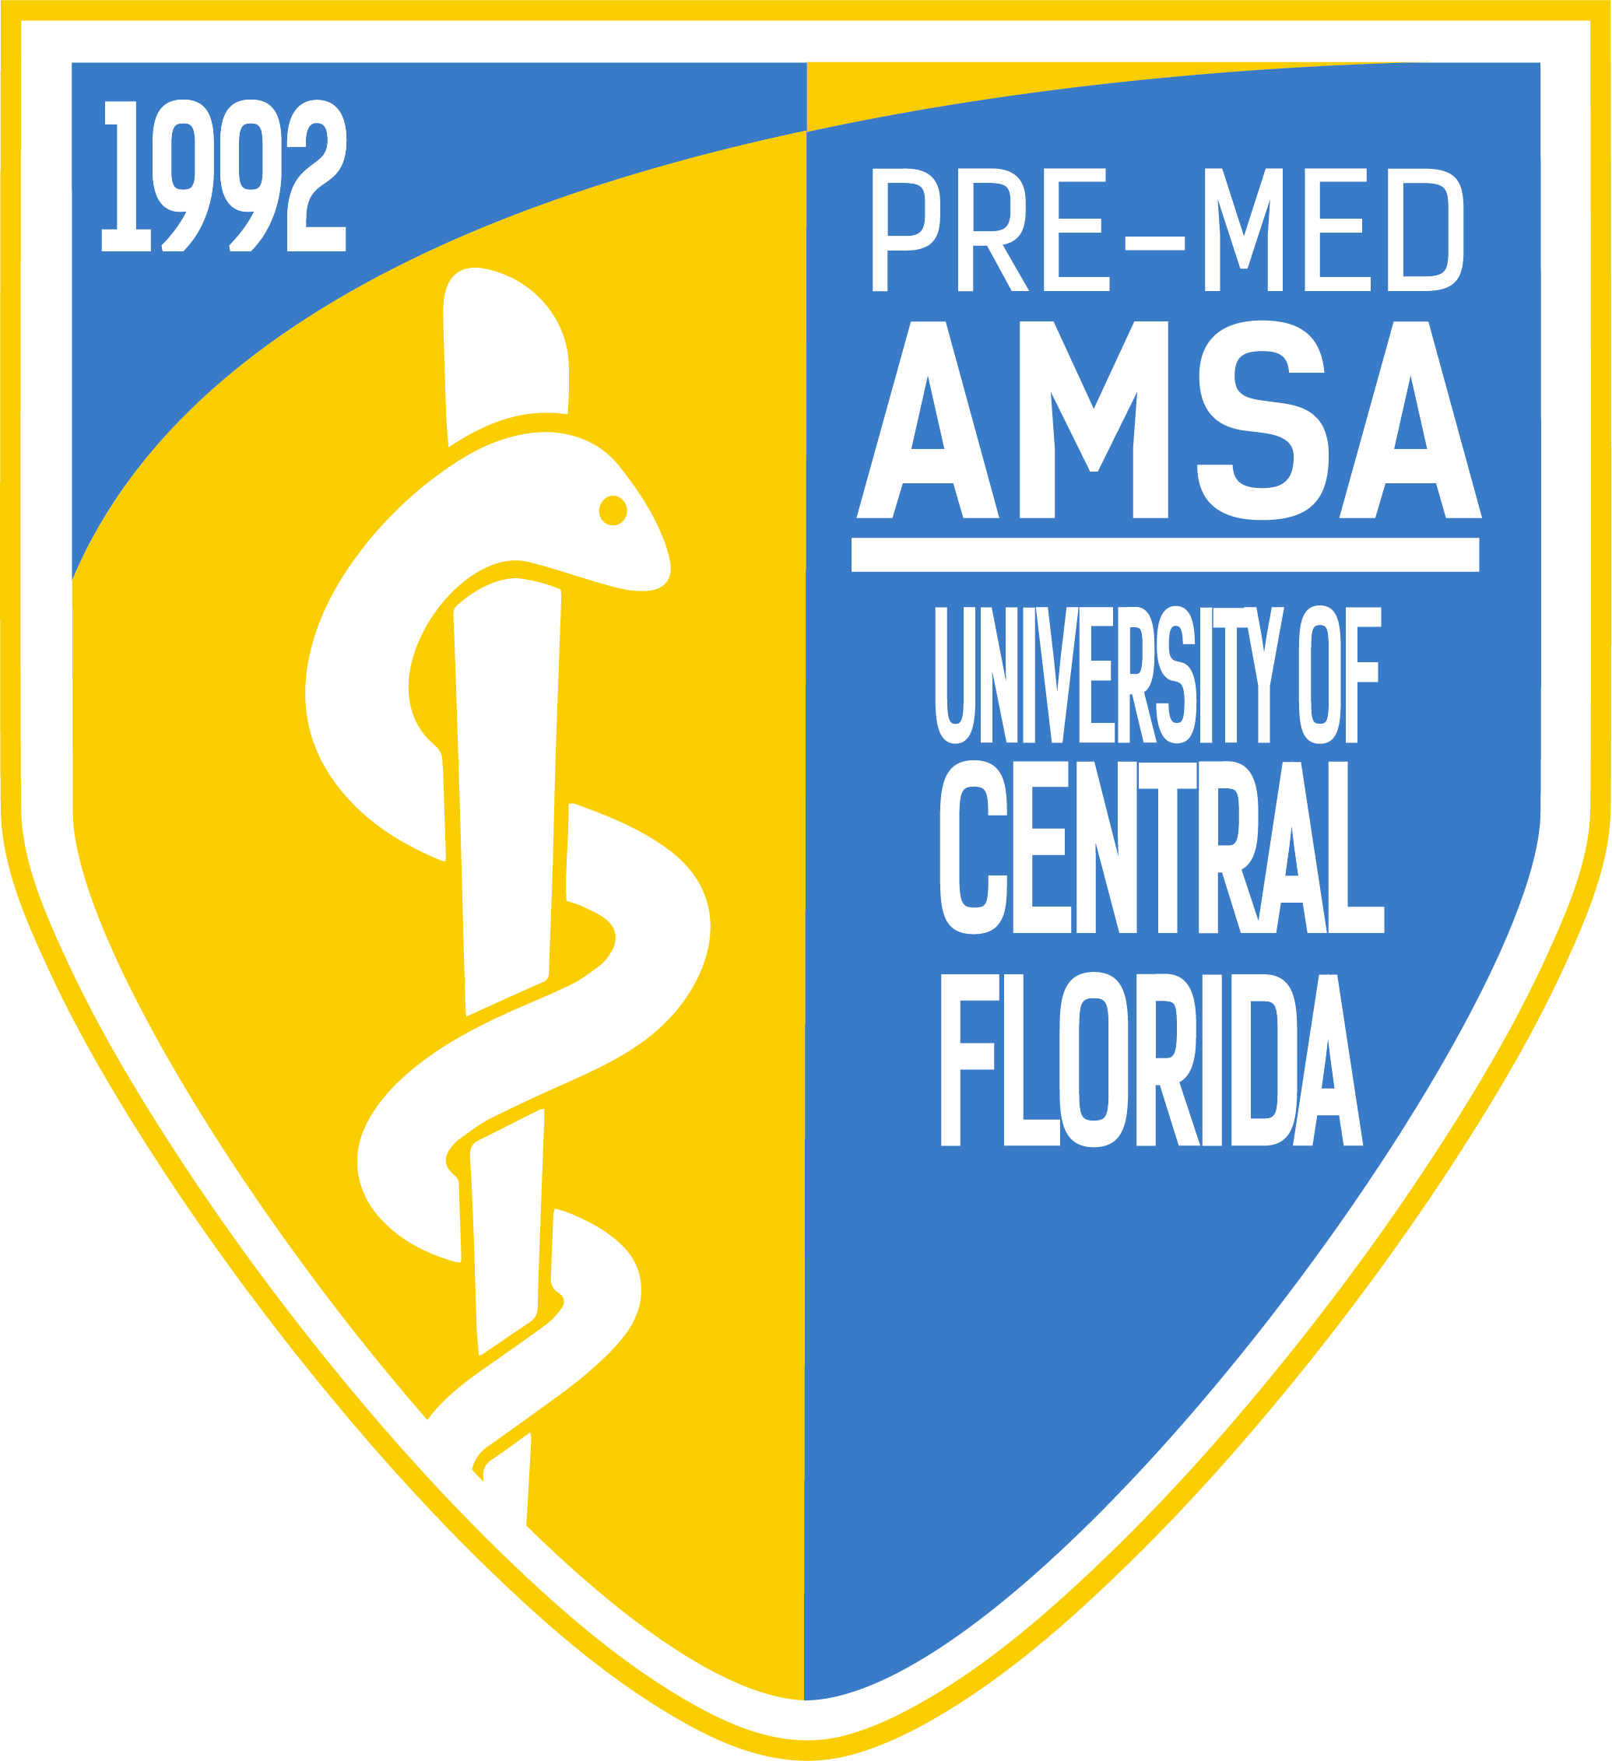
Pre-Med American Medical Student Association
Meeting Minutes
Officers: Emily Woolhiser, Salvador Corona, Anishaa Sivakumar, Taylor Duffy, Sophia Dias, Ariel Perry-Mills
Meeting Date: Tuesday, September, 11th 2018

I. Topics of Discussion
1. Moment of silence for those that lost their lives on 9/11/2001
2. Introducing newly-elected Directors
3. Executive Board recapping past events and highlighting those that are upcoming
4. Dr. Fernando I. Rivera, UCF faculty member, speaks on disaster scenarios and the practice of medicine
5. Raffle
II. Discussion
1. Pre-Med AMSA takes a moment of silence for all the victims of 9/11/2001.

2. Emily Woolhiser (President)
- Directors
  - Operations
    - Introduced our very first committee sign-ups. Becoming a Committee Members is a great way to get more involved in AMSA, develop leadership and organizational skills, and ultimately strengthen your medical/graduate school application
    - Dr. Putzer Event!
      - 9/16 @ 6:00 PM in HPA 112, this Sunday!
      - Dr. Putzer MD/PhD, is a professor at UCF and one of our favorite speakers each and every year. Unfortunately, he does not have the availability to speak at a General Body Meeting this year. Therefore, we will be hosting an event with him this Sunday, September 16th at 6:00 PM in HPA 112.
        - Those who attend will receive 3 AMSA Points, with an extra point if come wearing AMSA gear.
    - World Heart Day
      - 9/29 from 9:00 AM to 12:00 PM.
      - For World Heart Day, 9/29, the Sanford and Altamonte campuses of Seminole Stage College, Central Florida Regional Hospital, and Orlando Health South Seminole Hospital will be offering CPR and AED training at each of their respective locations, from 9:00 AM to 12:00 PM
    - New Directors
      - Operations
        - Reetish Singla
        - Anna Jurlina
        - Riya Shah
- Salvador Corona (Vice President)
  - Directors
    - Wellness & Student Life
    - Health Policy
    - Global Health
    - Relay for Life
      - Relay for Life Interest
        - Every year AMSA takes part in Relay for Life, an event that fights back against cancer. If you have any questions or interest in joining AMSA’s Relay for Life team, please our Relay for Life directors at relayforlife@premedamsa.com

      - IM Football on Mondays
        - If you have any interest in joining the co-ed IM Flag Football team, please e-mail our Wellness and Student Life directors at: wellnessandstudentlife@premedamsa.com
      - New Directors
        - Wellness & Student Life
          - Zach Schwartz
          - Sophia Jardon
          - Dylan Mackey
        - Health Policy & Equality
          - Grace Morton
          - Isaac Salazar
        - Global Health
          - Samantha Gallahan
          - Demani Barnes
        - Relay for Life
          - Rebecca Reeves
          - Danielle Duffet
- Anishaa Sivakumar (Treasurer)
  - Directors
      - Fundraising
        - Dues
          - Discussed the process of paying dues which is outlined within the “How to Join” tab on our website, premedamsa.com. For those that would like to attend events, you must be a paid member. Anybody with questions related to dues are encouraged to contact Anishaa at treasurer@premedamsa.com
          - Those that would like to pay for dues before our next General Body Meeting are encouraged to attend Anishaa’s office hours on Tuesdays between 3:00 – 4:00 PM.
        - Spectrum Fundraisers (9/21 and 11/1)
          - For those looking to support AMSA, receive 5 AMSA points, and/or gather volunteering hours, AMSA will be holding two Spectrum Fundraisers this semester. This is an event where we volunteer for the respective UCF football games on 9/21 and 11/1, with all of the money we get compensated for going straight to our Pre-Med AMSA chapter. This event is one of our greatest sources of fundraising and allows us to put on other great events throughout the school year.
          - Those looking to volunteer for any of the aforementioned Spectrum Fundraisers should e-mail treasuer@premedamsa.com. This event is mandatory for officers and directors!
        - Merch
          - AMSA will be selling Sweatshirts and Baseball Caps!
        - New Directors
          - Fundraising
          - Logan Blake
          - Neda Hamood
          - Talya Kohan
          - Trucvy Nguyen
          - Minh Vo
- Taylor Duffy (Secretary)
  - Directors
    - Mentorship
    - Academics
    - Career Development
      - Coffee with the COM
        - Discussed upcoming Coffee with the COM on 10/2 at 6:00 PM. This is an event in which a select amount of AMSA Members visit the UCF College of Medicine (COM) in Lake Nona hear from the Associate Dean, Dr. Verduin, speak with a medical student panel, along with a tour of the medical school itself! To RSVP for this great event, please email Taylor at secretary@premedamsa.com. Spots are limited and going quickly!
      - Mentor/Mentee Applications!
        - Applications to become a Mentee or Mentor within AMSA’s Mentorship Program can be found on our website, premedamsa.com, under “Forms”.
      - AMSA Library
        - Have any textbooks to let us borrow! AMSA will begin collecting donations for our very own AMSA Library! This library will be located at our AMSA Cubicle on the second floor of the Student Union and consist of textbooks that students may rent out on a weekly-basis.
        - The very first textbook you donate will give you 3 AMSA Points, with every forthcoming textbook adding +1 AMSA Points.
        - More information about our AMSA Library should be sent to academics@premedamsa.com
      - New Directors
        - Academics
          - Azalia Samsam
          - Abe Lesniewski
          - Emma DiFiore
        - Mentorship
          - Justin Britton
          - Kyle Fowler
        - Career Development
          - Chelsey Ameda
          - Meeti Mehta
- Sophia Dias (Sergeant at Arms)
  - Directors
    - Knight-Thon
    - Medical Relations
    - Volunteering
      - 9/24: VA Bingo
        - Volunteer on Monday, September 24th at the Veteran Administration (VA) in Lake Nona.
      - 10/12: BASE Camp
        - BASE Camp is an organization that focuses on helping children who are patients at Arnold Palmer Hospital by bringing dinner and a movie to a handful of kids on Friday nights.
        - To RSVP for this event, please e-mail sergeantatarms@premedamsa.com
        - Clean the World from 9:00 AM to 11:00 AM
        - 9/10: VA Bingo from 6:00 PM – 7:30 PM
          - Those interested in any of the aforementioned volunteer events are encouraged to e-mail Sophia at sergeantatarms@premedamsa.com
        - Knight-Thon Interest Meeting
      - Recapping our successful Clean the World and VA Bingo volunteer events this past week!
      - New Directors
        - Knight-Thon
          - Katelyn Gomez
          - Johanna Villadraez
        - Medical Relations
          - Antonio Mele
          - Nikki Anne Ballelos
        - Volunteering
          - Sakshi Sarkar
          - Sam Vilarino
          - Melanie Molina
          - Lorraine Bermudez Rivera
- Ariel Perry-Mills (Chief of Staff)
  - Directors
    - Media Relations
    - Newsletter
    - Research
      - AMSA Points
        - AMSA Points can be earned by attending General Body Meetings, events, and even by following AMSA on each of our respective social media accounts. If 50 points are reached in a given semester, the given AMSA member will be honored as a Distinguished Member, with future perks coming along with the title. Any questions or discrepancies about points are encouraged to email Ariel at chiefofstaff@premedamsa.com
      - New Directors
        - Media Relations
          - Addison Brown
          - Sunmi Jin
          - Sophie Risi
          - Daniela Velez
          - Nina Steele
          - Victoria Millington
        - Newsletter
          - Juliet Cahow
          - Lily Tehrani
        - Research
          - Mate Nagy
          - Lindsay Martin

III. Dr. Fernando I. Rivera
- Dr. Fernando I. Rivera discusses disasters and the practice of medicine.
  - The natural response, physiologically and psychologically, to disasters.
  - Global and U.S. Disasters that have changed the way we prepare as citizens, hospitals, and practitioners.
    - 9/11
    - Hurricane Katrina
    - Hurricane Sandy
    - Hurricane Maria
  - The role of a physician in a time of disaster when there is a shortage of practitioners and health professionals present
  - The differences between how Puerto Rico and how the United States have handled the medical needs of those during disasters
  - What we can do to help
IIII. Raffle
1. Raffled off Starbucks Gift Cards, Vintage AMSA T-Shirts, and a set of MCAT Flashcards to members taking part in the free raffle.
V. Roundtable w/ the Executive Board

